**Pre-requisite**

Please make sure to download the Java 1.8 and Maven on to the system. Set the environment variables.

**To import the project…**

1. Import the .POM file from the UKSBS\pom.xml
2. After the successful import, run mvn dependency:resolve
3. Packages will be downloaded, After that, run mvn clean install -DskipTests for compilation

**Framework explanation in short:-**

**POM.XML File:**- For all the dependencies, plugins and Profiles and report settings.

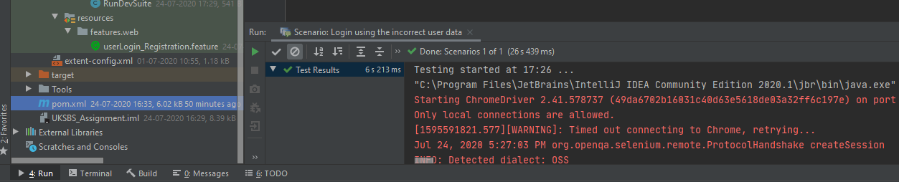

**profile/dev/config.properties:-** For the base URI. This file can be used for further parameters

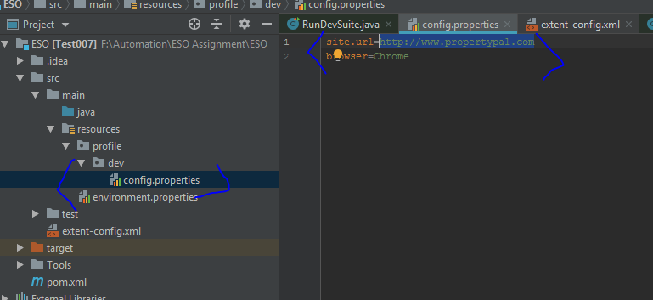

**Environment.properties:-** This file will take the default profile set at the .POM file.

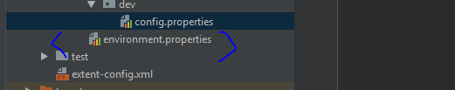

**src\test\java\com\uksbs\test\framework\CommonMethods\CommonMethods.java :-** This class will have all the common methods which will reduce the rework.

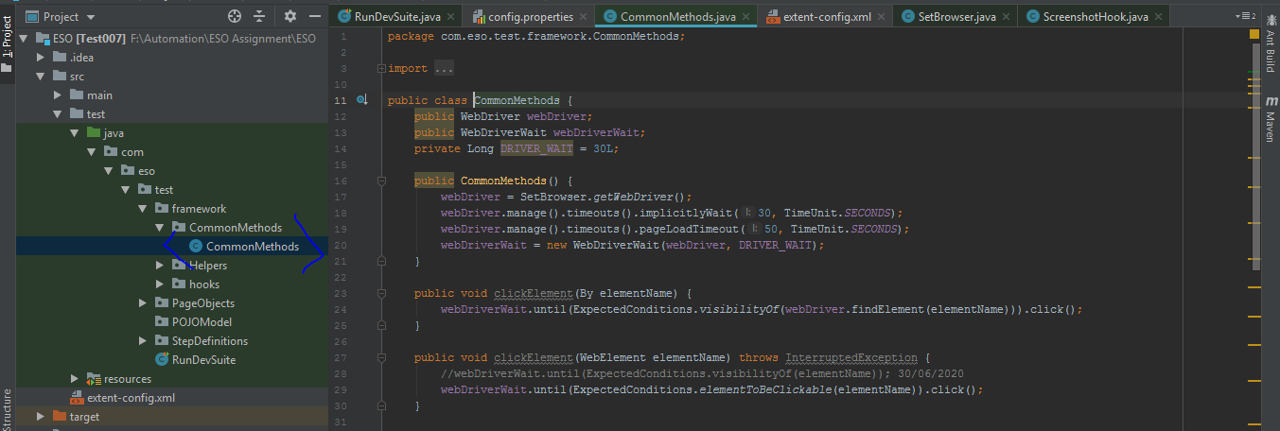

**src\test\java\com\uksbs\test\framework\Helpers**:- Helper folder will have all the helpers classes. Ex:- Build the URL, Take the screenshots etc

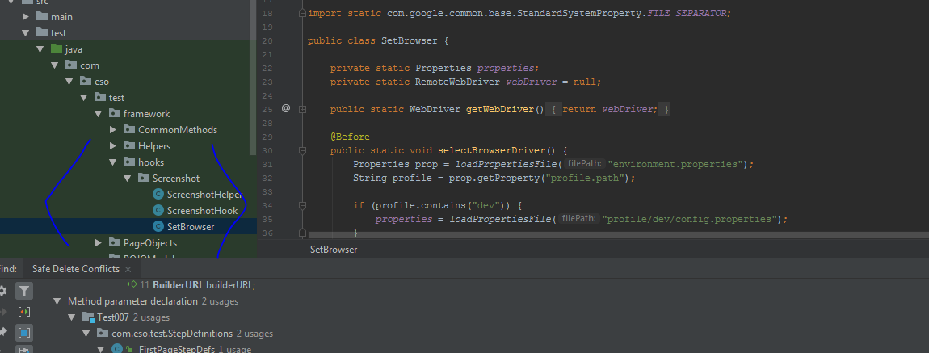

**src\test\java\com\uksbs\test\RunDevSuite.java:-** Runner class to run the feature files. We are using TestNG here (and at feature files for Assertions)

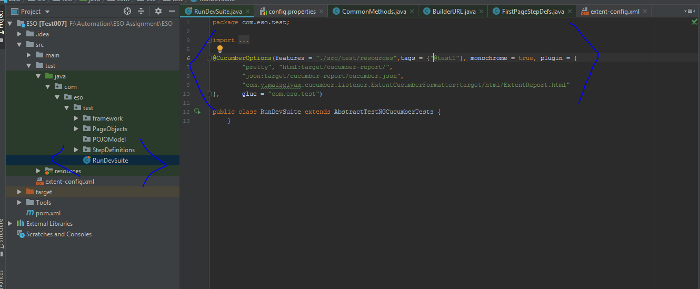

**features/web/propertySearch.feature:-** All the feature filles will be residing in this folder

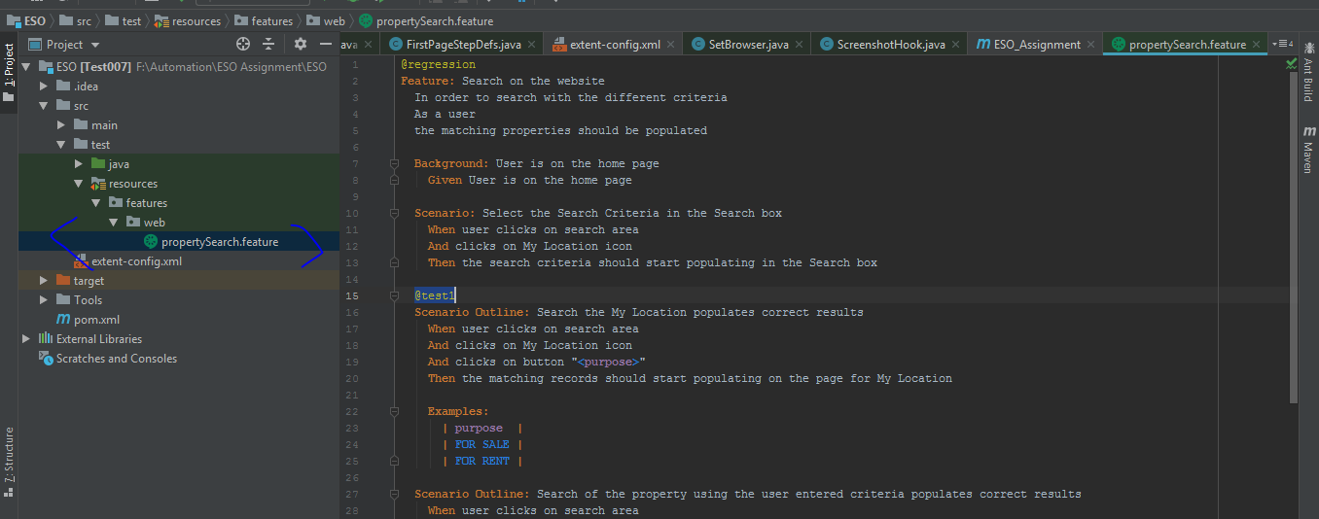

**ESO\target:-** This folder will have generated reports and resources

**How to run the scripts**

Run the scripts from the runner file to view the Extent report

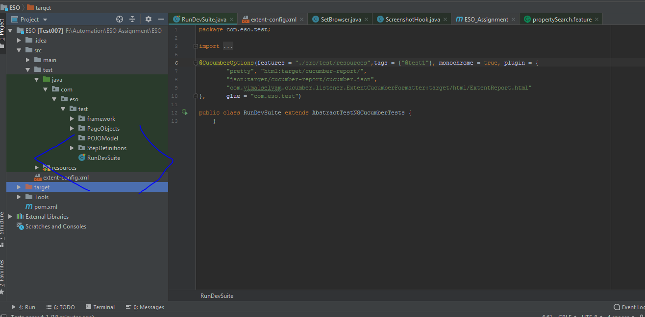

Extent Report Folder location

